|  |  |  |  |  |  |
| --- | --- | --- | --- | --- | --- |
| **Project Name:**  Manorfield Hall  Hall Hire | **Address of where project is taking place:**  Newhall Road  Leeds LS10 3RR | **Person undertaking Risk Assessment:**  Ian Rodley | | | |
| **Project start date:**  June 2024 | **Date of Risk Assessment:**  20/06/2024 | | | |
| **Description of project:**  The hall is able to be hired for activities/events by a company or member of the public for them to use as they wish, with the availability of kitchen use if they wish but must be agreed in the terms and conditions. | | | | | |
| **If food is being served from an outside source are the Food Hygiene Certificates in date?** | | | **YES** | **NO** | **N/A** |
| **If an outside company is hosting the event/ project, do you have a copy of their Public Liability Insurance, Risk Assessment and emergency arrangements** | | | **YES** | **NO** | **N/A** |
| **If you are inviting outside organisations to the event, have you got a copy of their Public Liability Insurance and Risk Assessment** | | | **YES** | **NO** | **N/A** |
| **Is there trained First Aid staff/persons available during the event?** | | | **YES** | **NO** | **N/A** |
| **Any comments or concerns:** | | | | | |

**Manorfield Hall Hall Hire Risk Assessment**

**Information page**

**What is a hazard?**

A hazard is a source or a situation with the potential to cause harm in terms of human injury or ill-health, damage to property, damage to the environment, or a combination of these.

**What is a risk?**A risk is the chance or likelihood of a hazard causing harm.

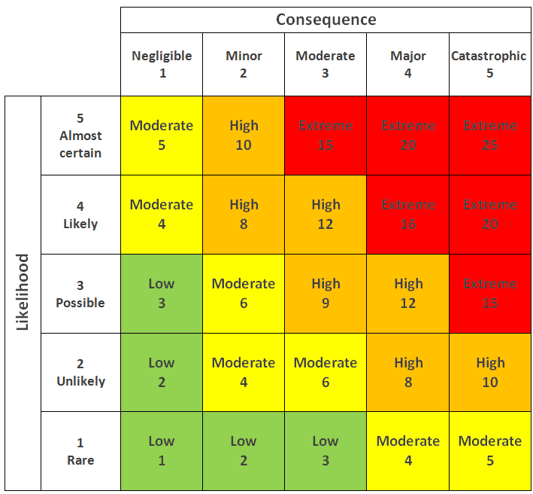**What is a risk assessment?**A risk assessment is a systematic process of identifying hazards and evaluating any associated risks, then implementing reasonable control measures to remove or reduce the risks involved in your project or workplace. Risk assessments are working or ‘live’ documents, they should be regularly reviewed and updated with your experience and learning.

**What is a risk matrix?**

A risk matrix is a matrix that is used during risk assessment to define the level of risk by considering the category of likelihood against the category of consequence severity. This is a simple mechanism to increase visibility of risks and assist management decision making.

E.g. Likelihood 2 x Consequence 4 = 8 (Amber)

|  |  |  |  |  |  |  |
| --- | --- | --- | --- | --- | --- | --- |
| **What are the hazards** | **Who might be harmed and how** | **Pre- control risk level** Likelihood x Consequence | **What are you doing to control the risk posed by these hazards?** | **Post-control risk level** | **Do you need to do anything else to control the risk?** | **Action by who and by when?** |
| Misuse, loss, accidental sharing of service user information | Hirer of Manorfield Hall | Likelihood (3) x Consequence (3) = (9) High | We limit the amount of information we take form hall users. The only information we take is  Contact name, address and number of hirers so that we are able to assist in the track and trace system. We do have the app code that we encouraged uses to scan too.  This information is collected by Ian Rodley and DAZL and are stored on a password protected laptop and only DAZL has access. Any contracts or invoices are kept in a File on the secure online system. | Likelihood (2) x Consequence (1) = (2) Low | Make sure information is password protected and contracts are in a file on the secure online system. | EPG when the spreadsheet or invoices/contracts are created. |
| Slips, trips and falls in the Hall | Users of Manorfield Hall | Likelihood (3) x Consequence (4) = (12) High | We ask the Hall Hirer to keep the hall floor as clear as possible when any activities are been done.  In the event of a spillage, we have mops and paper towels designated for this purpose.    We insist that a first aider is on sight at all times and any First Aid boxes are kept in the bottom draw in the kitchen which is labelled. | Likelihood (1) x Consequence (2) = (2) Low | Check floor space regularly and make sure any spillages are clean appropriately and signs are used if needed. | EPG when the session begins. The responsibility after this is of the Hall Hirer. |
| Mis-use of the kitchen and equipment. | Hirer of Manorfield Hall | Likelihood (3) x Consequence (4) = (12) High | We advise that only the hirer or a responsible adult in their team uses the kitchen and the equipment. We ask that children under the age of 16 are not in the kitchen at any time. | Likelihood (1) x Consequence (2) = (2) Low | Before the hirer is allowed to access the hall, they must read and sign the terms of the agreement that is given by EPG. A signed copy is kept on site and is revied on when stated on the contract. | EPG to send a copy of terms and conditions to the hirer before the event. |
| Problems accessing the building | Users of Manorfield Hall | Likelihood (2) x Consequence (1) = (2) Low | The building is accessible through the front gate and car park. Entrance then main building is through the maid double doors at the front of the building, all hall uses are required to use this entrance and exit to the building  All entrances are wheelchair and pushchair friendly. | Likelihood (1) x Consequence (1) = (1) Low | Make sure all entrances and exits are clear at all times the hall is been used including emergency exits. | EPG when setting up the room then this responsibility is passes to the hall hirer. |
| Fire risk | All users of Manorfield Hall | Likelihood (3) x Consequence (5) = (15) Extreme | Fire alarms are in place and checked every year. There are also “Fire Brake Glass” units around the hall if needed.  In the event of a fire there are visible signs to assist the users of the hall were to go and access to fire extinguishers. | Likelihood (1) x Consequence (5) = (5) Moderate | Fire alarm and fire extinguishers checked yearly. | EPG check all equipment before uses of the hall arrive.  EPG to book fire check each year. |

|  |  |  |  |  |
| --- | --- | --- | --- | --- |
| I confirm that I have read and understood this risk assessment and the controls which need to be followed to minimise injury and ill-health | | | | |
| Name  Ian Rodley (DAZL) | Signature |  | Date  20.06.24 |  |
| Name  Christine Webb (Manorfield Hall) | Signature |  | Date |  |
| Name | Signature |  | Date |  |